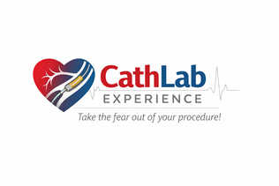
Thank you for your interest in www.cathlabexperience.com! We look forward to being a consistent resource as you and your family go through the steps of a heart cath procedure. Please be sure to email us in the future with any questions you may have along this path. Included in this email is a graphic to help make sense of the score you received on your heart health assessment from the American Heart Association. Please keep in mind, we are not able to give medical advice and any suggestions or additions to your wellness path should be discussed with your doctor first. Once again, we look forward to being a resource with you on this journey and thank you for checking out www.cathlabexpereince.com!

Sincerely,
www.cathlabexperience.com
